**To Set Grafana Home Page**

Following are the steps to set dashboards list as home page in Grafana: -

1. First mark all the dashboards of Grafana as star. Like: -

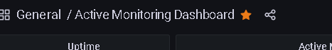

1. Then go to the Configuration from sidebar.



1. Then select Preferences.

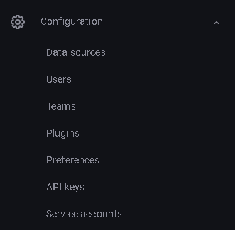

1. Then go to the Home Dashboard option.

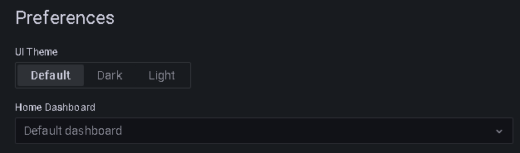

1. Select the dashboard named General/Home. 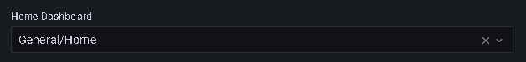
2. Then save it and it will update the home page of Grafana.

Note: - Check it by logout and login again.